VIETNAM INTERNATIONAL UNIVERSITY – HO CHI MINH CITY

INTERNATIONAL UNIVERSITY



WEB APPLICATION DEVELOPMENT PROJECT

SHOES SHOPPING ONLINE

**Members of Group:**

Lê Thành Đại Dương_ITITUN14002

Vương Khắc Duy_ITITUN14010

Ninh Thế Lâm_ ITITUN14007

GitHub Link: <https://github.com/tieuduong241096/2017S2-WEB_LAB->

# Introduction

**1.1 About us**

This section will bring you the background information of our web product. The abstract description about the product that our team will design. Furthermore, the constraints which will affect our project is also included in this part.

|  |  |
| --- | --- |
| **Information** | **Details** |
| Team members | 3 members: Dương , Lâm , Duy |
| Business | Web Application Developement Project: **E-Commerce Web** |
| Customer | International University – Viet Nam National University Ho Chi Minh City |
| Contact | Office: 6th floor, A Block, International University, Thu Duc, HCMC.  Email:  Tel: |

* 1. **Overview**

**Project Title** – **E-Commerce Web**

**Objective**

* To develop a web application that allows a registered customer to purchase a variety of shoes by a list of registered shops.
* To provide an easy to use Interface.

**Basic Requirements**

* ***Customer***
* Secured registering and managing their profiles.
* Easy navigation through pages.
* Secured Payment gateway.
* ***Shop owner***
* Secured registering and managing their profiles.
* Add, delete or modify the already posted products.
* ***Administrator***
* Authority to approve and reject requests for new items.
* Can control customers and shop owners actions.
  1. **Project Scope**
* *Scope – In*
* Websites for desktop, which is compatible with IE, Mozilla, Chrome etc.
* Purchase products available in the website.
* *Scope – Out*
* Payment Gateways to be linked through APIs.
* Not compatible for mobile users.
* *Users*
* Customers
* Shop owners
* Administrators

# Use Case Diagram

## USE CASE 1:

**Name**: Search Product

**Description:** The list of products is showed when the user input the name of products which they want to find.

**Identifier** UC6

**Inputs**: Input desired product name

**Output**: Show all products that have the letters that user typed in

**Basic Course**

|  |  |
| --- | --- |
| ACTOR(User) | SYSTEM |
| 1.Input Product name | Display the all of products |
| 2.Click on The product | Display the photo and name of product |

**Precondition:** None

**Post condition:** None

**User Story:** As a customer, I want to search the products.

## USE CASE 2:

**Name**: Purchase History

**Description:** Show the list of purchase information of the user

**Identifier**: UC2

**Inputs**: User ID

**Output**: Information of purchase history

**Basic Course**

|  |  |
| --- | --- |
| ACTOR(User) | SYSTEM |
| 1. Login | Display login page |
| 1. Input User Name and Password |  |
| 1. Submit | * Check username and password * If true, show the purchase history * Else return to Login |

**Precondition:** Users have to log in with their own account.

**Post condition:** None.

**User story:** Customers can check the purchase history in the future.

## USE CASE 3:

**Name**: Recommend

**Description:**

**Identifier** UC3

**Inputs**:

**Output**: The list of recommend product based on mutual friends interesteds

**Basic Course**

|  |  |
| --- | --- |
| ACTOR(User) | SYSTEM |
| 1. Login |  |
| 1. Input    * The name of products into the search products.    * Click recommend products button. |  |
| 1. Submit | * Show the list of recommend products. |

**Precondition:** None

**Post condition:** None

**User story:** The list of recommend products.

# System Architecture

1. **Sequence Diagram**
2. **Recommend product**

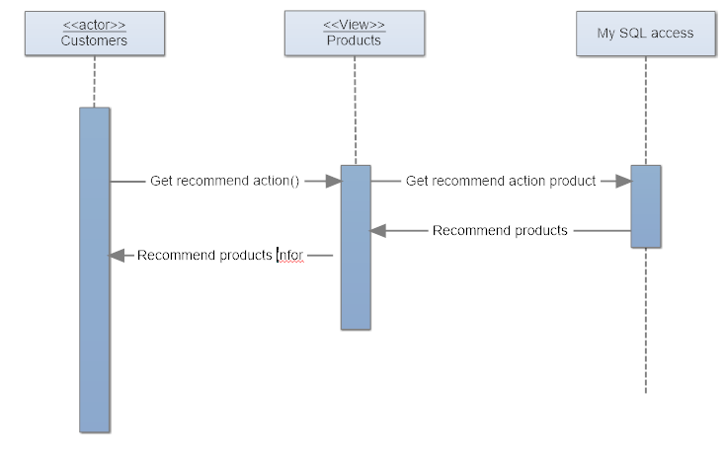

1. **Purchase History**

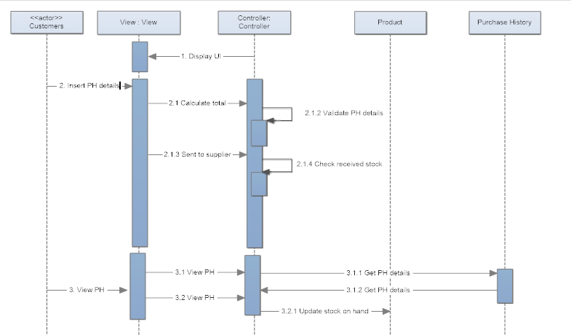

1. **Search product**

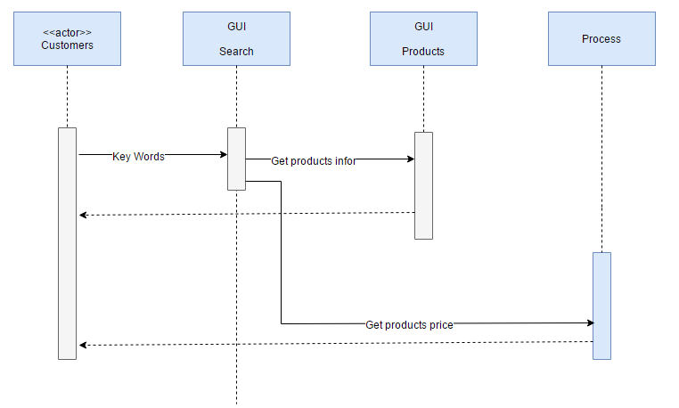

1. **Class Diagram**

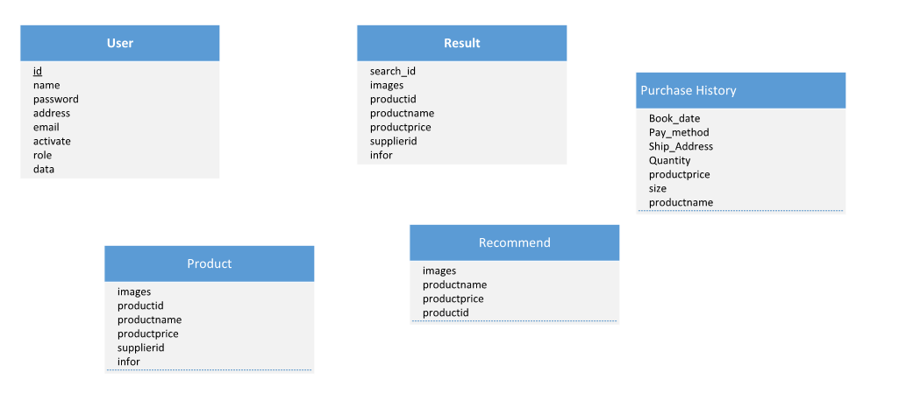

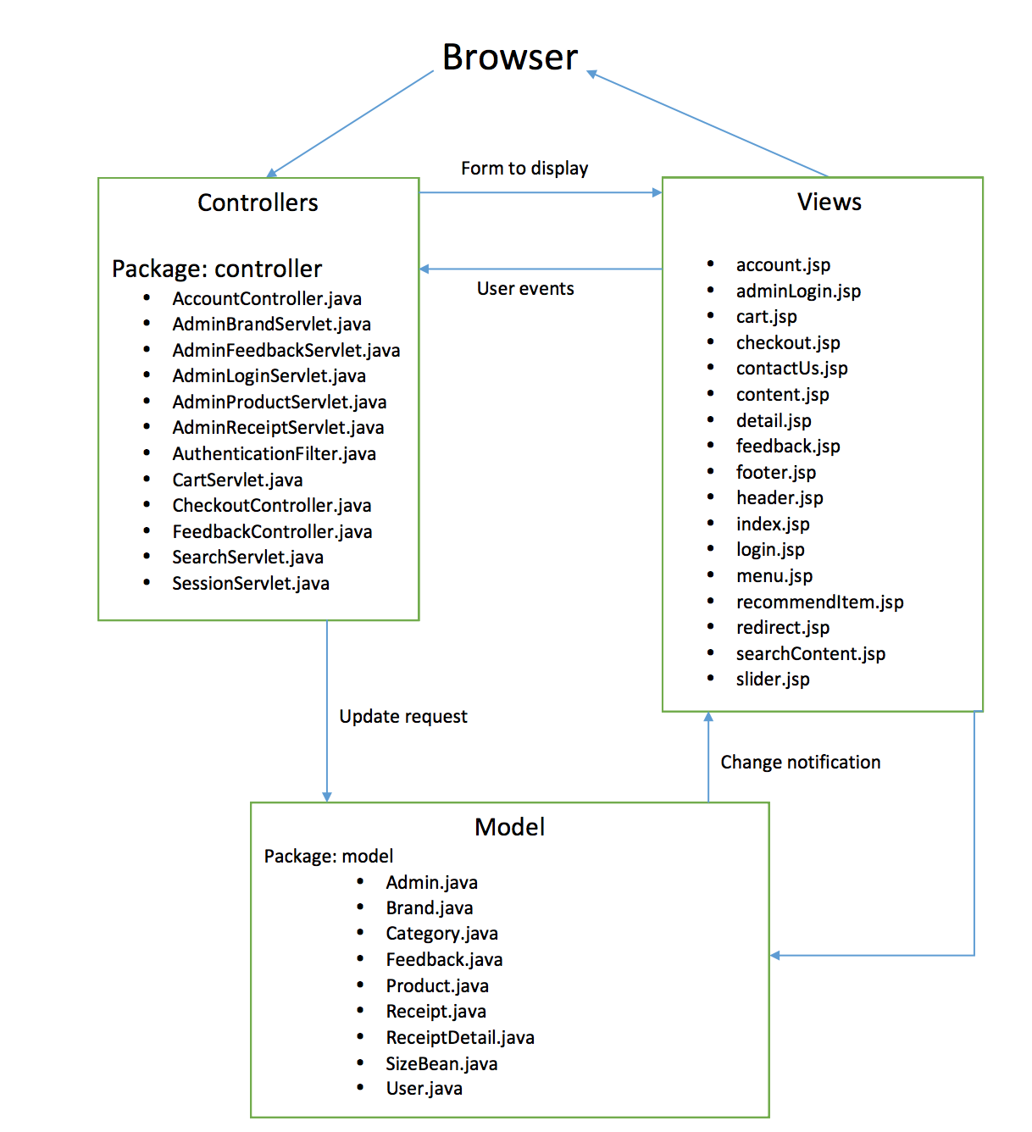

# Database Design

Tables Design

|  |  |  |  |  |  |
| --- | --- | --- | --- | --- | --- |
|  | **Table** | **No of Attribute** | **Primary Key** | **Related Table** | **Foreign Key** |
| 1 | Product | 9 | ProductID | Brand, Category, ReceiptDetail | BrandID, CategoryID |
| 2 | Brand | 2 | BrandID | Product, Category |  |
| 3 | Category | 3 | CategoryID | Product, Brand | BrandID |
| 4 | Receipt | 6 | ReceiptID | User, ReceiptDetail | UserID |
| 5 | ReceiptDetail | 6 | ReceiptDetailID | Product, Receipt | ReceiptID,  ProductID |
| 6 | User | 10 | UserID | Feedback, Receipt |  |
| 7 | Feedback | 7 | FeedbackID | User | UserID |
| 8 | Admin | 2 | Name |  |  |

Entity Description

**PRODUCT**

|  |  |  |  |  |  |  |  |
| --- | --- | --- | --- | --- | --- | --- | --- |
| Field name | Type (size) | Identity | NULL | PK | FK | References | Description |
| ProductID | int | yes | no | PK |  |  | Product identity number |
| ProductName | varchar(255) |  | no |  |  |  | Product Name |
| ProductPrice | double |  | no |  |  |  | Product’s Price |
| ProductImage | varchar(255) |  | no |  |  |  | Product’sImage |
| ProductQuantity | int |  | no |  |  |  | Product’s Quantity |
| Description | varchar(255) |  |  |  |  |  | Product’s Description |
| Discount | double |  |  |  |  |  | Product’s Discount |
| BrandID | int |  | no |  | FK | Brand(BrandID) | One brand has many products |
| CategoryID | int |  | no |  | FK | Category(CategoryID) | One category has many products |

**USER**

|  |  |  |  |  |  |  |  |
| --- | --- | --- | --- | --- | --- | --- | --- |
| Field name | Type (size) | Identity | NULL | PK | FK | References | Description |
| UserID | int | yes | no | PK |  |  | User identity number |
| UserName | varchar(30) |  | no |  |  |  | User name to login |
| Password | varchar(30) |  | no |  |  |  | User’s password to login |
| UserAge | int |  | no |  |  |  | User age |
| UserGender | bit |  | no |  |  |  | bit 1: Male; bit 0: Female |
| UserAddress | varchar(255) |  | no |  |  |  | User’s Address |
| Email | varchar(255) |  | no |  |  |  | User’s Email |
| FullName | varchar(255) |  | no |  |  |  | User’s FullName |
| Phone | varchar(15) |  | no |  |  |  | User’s Phone |
| Status | bit |  |  |  |  |  | bit1: active; bit 0: inactive |

**PURCHASE HISTORY**

|  |  |  |  |  |  |  |  |
| --- | --- | --- | --- | --- | --- | --- | --- |
| Field name | Type (size) | Identity | NULL | PK | FK | References | Description |
| ReceiptDetailID | int | yes | no | PK |  |  | Receipt Detail identity number |
| Quantity | int |  | no |  |  |  | User’s prefered quantity |
| price | double |  | no |  |  |  | Total Price (productPrice * quantity) |
| ReceiptID | int |  | no |  | FK | Receipt(ReceiptID | one receipt has many receipt detail |
| ProductID | int |  | no |  | FK | Product(ProductID) | One receipt detail has many product |
| size | double |  | no |  |  |  | User’s prefered shoe size |
| date | Dd//mm/yy |  | no |  |  |  | Booking date |

**ADMIN**

|  |  |  |  |  |  |  |  |
| --- | --- | --- | --- | --- | --- | --- | --- |
| Field name | Type (size) | Identity | NULL | PK | FK | References | Description |
| Name | varchar(255) | yes | no | PK |  |  | Admin name |
| Password | varchar(255) |  | no |  |  |  | Admin Password |

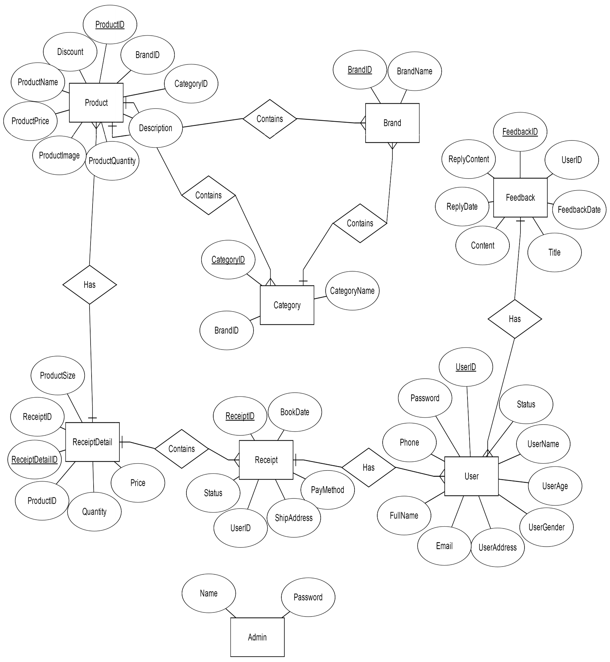ERD